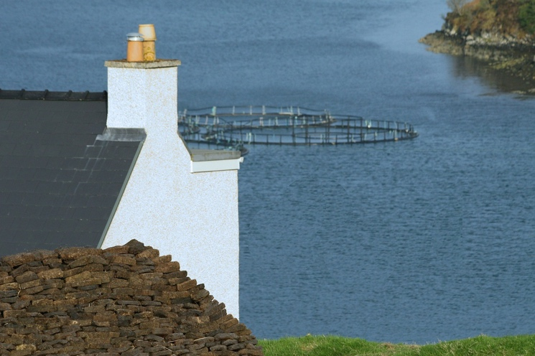
Scientist in the Spotlight

Claire McDonald
Fish Farm Technician

Q: How would you describe your job briefly?
A: I am a fish farm technician, or simply, a fish farmer. I work on a sustainable seawater fish farm that looks after and grows Atlantic salmon, which eventually end up in supermarkets and restaurants all over the world.

Q: What does your typical day look like?
A: There are no two days the same, every day is different! But I suppose that is what happens when you work with animals. There are some things that have to be done every day, such as environmental checks (temperature, salinity, oxygen content, visibility and plankton checks), feeding the fish, checking the pens for dead fish and removing these, and sample health checks of the fish.

Q: What are some positive aspects of your job?
A: I get to work outside in a beautiful part of the world surrounded by incredible scenery and wildlife, including dolphins and whales. I spend very little time sitting in front of a computer screen! The feed conversion ratio for salmon is one of the lowest in animal protein production and my farm is one of the most efficient, which is something I am very passionate about as salmon farming is a sustainable way to use global resources to produce food.

Q: What would you say are the negative aspects or limitations of your job?
A: The fish farm that I work on is very exposed, which means that sometimes the weather can be pretty horrendous, especially in the winter. We often work in very wet and windy conditions, which is not much fun. When the weather is particularly bad, we cannot even get out to the farm and are stuck on the shore.

Q: How did you get into this career?
A: I completed a degree in Sustainable Development at the University of St Andrews before working as an environmental consultant for a large engineering firm, mainly looking at Environmental Impact Assessments. Although this was interesting, I quickly realised that working in an office behind a screen was not for me so I decided I wanted a change. I went back to university to study a master’s degree in Sustainable Aquaculture at the University of Stirling, but also realised there is a lot about fish farming that you cannot learn in the classroom but can learn very quickly on the job! Very few people in the fish farming industry have university degrees, it is more important to be interested in it and passionate about sustainability.
Q: What advice would you give to pupils possibly thinking of a career in STEM?
A: Always do what you are most passionate and excited about and do not worry too much about getting the perfect job straight away, because this is actually very rare! The job I am doing now is so different to what I thought I would be doing when I left school but it has been the right path for me. Any work experience that you can get is good experience and you can apply anything you learn to any future job or career.

Activity
Use the scientist’s profile to answer the following questions:
- What is the scientist’s job?
__________________________________________________________________________________
__________________________________________________________________________________
- Briefly describe what the scientist does in a typical day.
__________________________________________________________________________________
__________________________________________________________________________________
- What skills do they need for this job?
__________________________________________________________________________________
__________________________________________________________________________________
- What do you think is the most interesting part of their job?
__________________________________________________________________________________
__________________________________________________________________________________
__________________________________________________________________________________
- Describe how this job links with the science you have learned in this unit
__________________________________________________________________________________
__________________________________________________________________________________
- State the definition of any words in bold from the scientist’s answers.
__________________________________________________________________________________
__________________________________________________________________________________
__________________________________________________________________________________

Additional notes:

+

-

Your opinion of this job:

Similarities between this scientist and you:

Describe this job in your own words:

Skills Needed for this job:
1.
2.
3.
4.
5.

Scientist Fact File

